*P250/1*

*GEOGRAPHY*

*PAPER 1*

*3 HOURS*



**ACEITEKA JOINT MOCK EXAMINATIONS 2023**

**UGANDA ADVANCED CERTIFICATE OF EDUCATION**

**(PHYSICAL GEOGRAPHY)**

**PAPER 1**

**3 HOURS**

**Instructions to candidates:**

* This paper consists of three sections **A, B,** and **C**.
* Answer only **FOUR** questions.
* Section A is compulsory.
* Answer only **ONE** question from section **B** and **ONE** question from section **C**.
* Credit will be given for the use of relevant sketch maps, diagrams and specific examples studied in the field.
* Any additional questions attempted will not be marked.

**SECTION A**

**QUESTIONS 1 AND 2 ARE COMPULSORY**

***Compulsory map work question.***

1. Study the map extract 1:50,000 (UGANDA) MASINDI sheet 39/3 series Y732 and answer the questions that follow:

(a)(i) Name the physical feature at grid reference 553891. (1 mark)

(ii) State the grid reference of Kibenya trigonometrical station. (1 mark)

(b)(i) Draw a relief (cross) section along Easting 58 between Northing 76 and 85 and on it mark and name.

* River Kabagarama
* Forest
* Gentle slope
* Ridge
* Road
* Settlements. (10 marks)

(ii) Calculate the vertical exaggeration of the relief section. (2 marks)

(c)(i) Describe the settlement patterns in the area covered by map extract.

(2 marks)

(ii) Explain the factors which have influenced the distribution of settlements in the area shown on the map. (6 marks)

(d) Explain the factors which have influenced the location of Masindi town.

(3 marks)

***Compulsory Photograph question.***

1. Study the photograph provided below and answer question that follow:

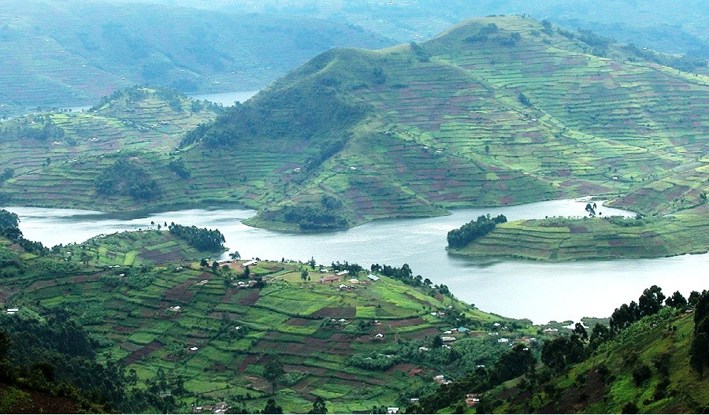

(a) Draw a landscape sketch of the photograph and on it mark and name:

(i) Land forms: Bay, headland, Lake Basin, highland.

(ii) Land uses. (10 marks)

(b) Describe the processes for the formation of headland. (4 marks)

(c)(i) Account for the land use types in the area shown in the photograph.

(4 marks)

(ii) Giving evidence explain the problems faced by people living in the area shown in the photograph. (5 marks)

(d) Giving reasons for your answer suggest one area in East Africa where this

photograph could have been taken. (2 marks)

**SECTION B**

1. Account for the occurrence of landslides in any **ONE** highland area in East Africa. (25 marks)
2. (a) Explain the causes of limited glacial activity in East Africa. (5 marks)

(b) Describe the processes for the formation of the following glacial features in East Africa:

(i) Corrie (7 marks)

(ii) Glacial trough (7 marks)

(iii) Roche mountonnée (6 marks)

1. To what extent does Darwin’s theory explain the formation of coral landforms in East Africa? (25 marks)

**SECTION C**

1. (a) What is an Air mass? (7 marks)

(b) Examine the influence of Air masses on the climate of East Africa.

(18 marks)

1. (a) Account for the growth of Savanna grasslands in East Africa. (15 marks)

(b) Explain the problems associated with land use in savanna grassland areas of East Africa. (10 marks)

1. To what extent has topography influenced the formation of soil types in East Africa? (25 marks)

**END**